Project 3: Data Analytics using MySQL
Overview
This project demonstrates basic data analysis using SQL on an e-commerce dataset imported into MySQL.

Objective
- Import CSV data into MySQL.
- Perform data analysis using SQL.
- Apply SQL clauses and aggregate functions.
- Generate business insights.

Tools Used
- MySQL Workbench
- MySQL Database
- Microsoft Excel
- CSV Dataset

Dataset Columns
- OrderID
- Date
- CustomerID
- Product
- Quantity
- UnitPrice
- ShippingAddress
- PaymentMethod
- OrderStatus
- TrackingNumber
- ItemsInCart
- CouponCode
- ReferralSource
- TotalPrice

SQL Operations
- SELECT
- WHERE
- ORDER BY
- GROUP BY
- COUNT()
- SUM()
- AVG()

SQL Queries Used
- SELECT COUNT(*) AS Total_Orders FROM data;

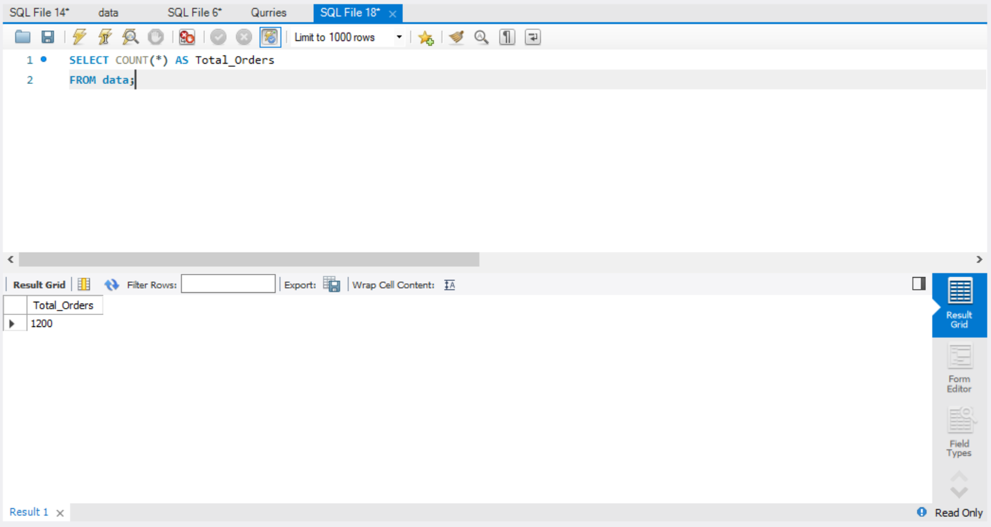

- SELECT SUM(TotalPrice) AS Total_Sales FROM data;

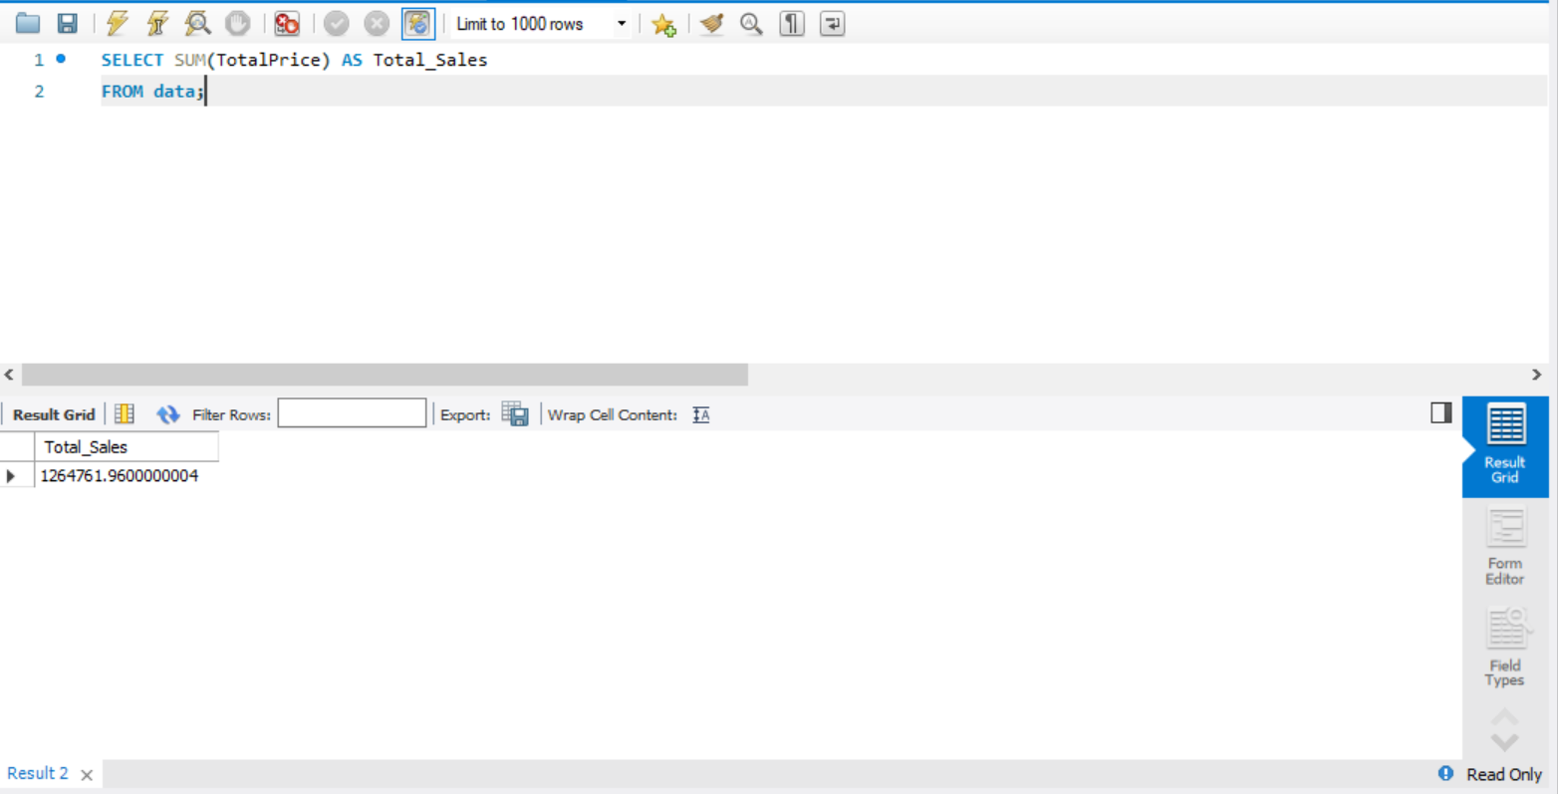

- SELECT AVG(UnitPrice) AS Average_UnitPrice FROM data;

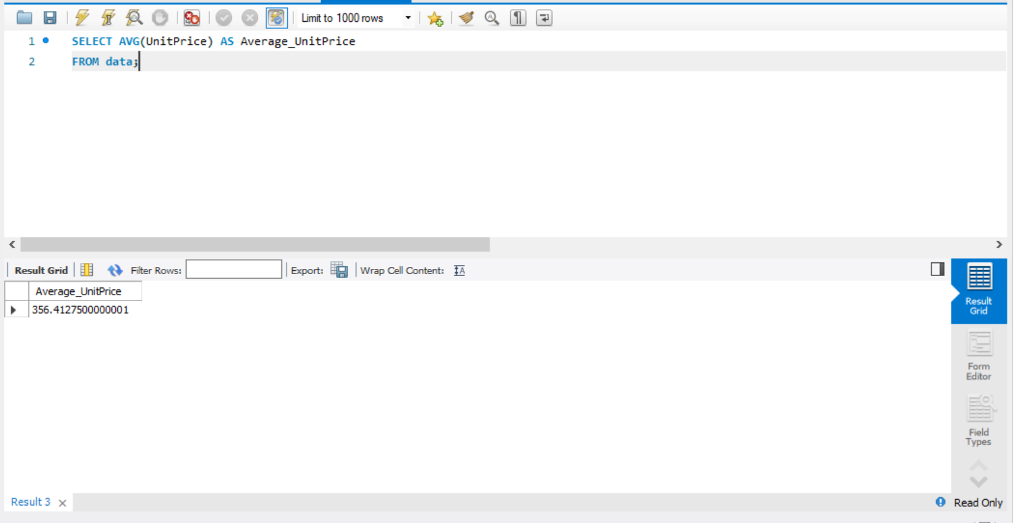

- SELECT AVG(Quantity) AS Average_Quantity FROM data;

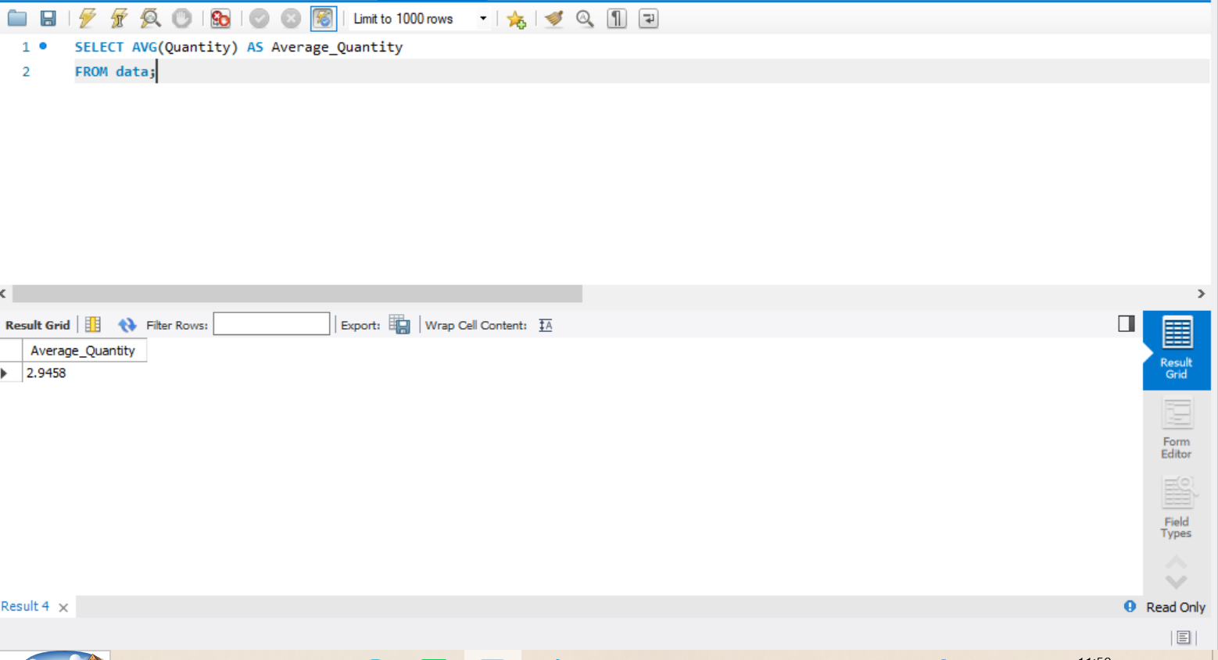

- SELECT Product, SUM(Quantity) AS Total_Sold FROM data GROUP BY Product ORDER BY Total_Sold DESC;

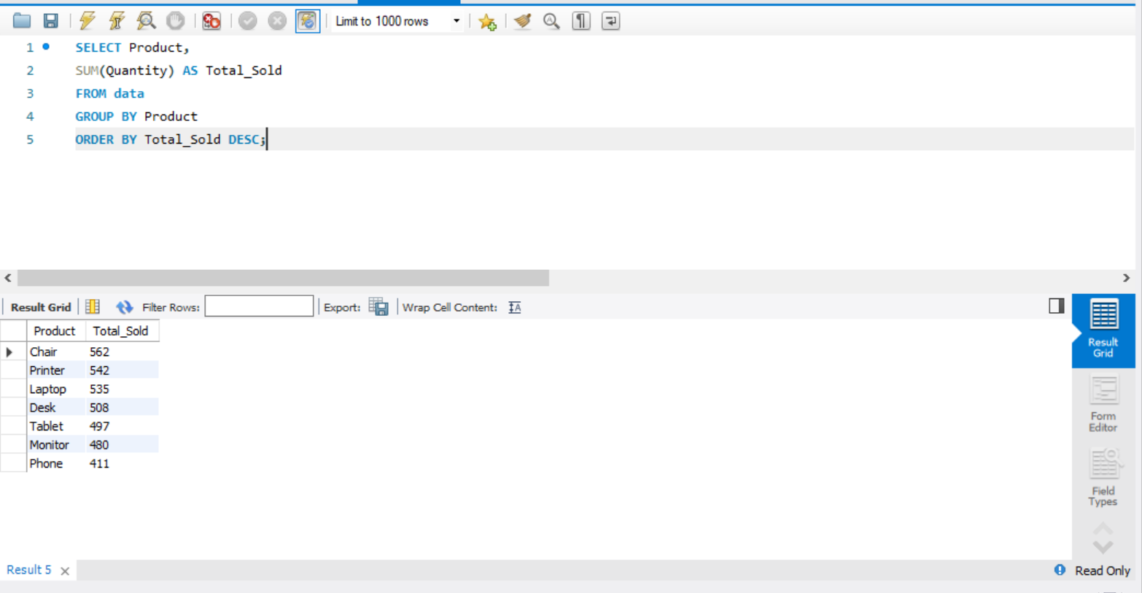

- SELECT PaymentMethod, COUNT(*) AS Total FROM data GROUP BY PaymentMethod;

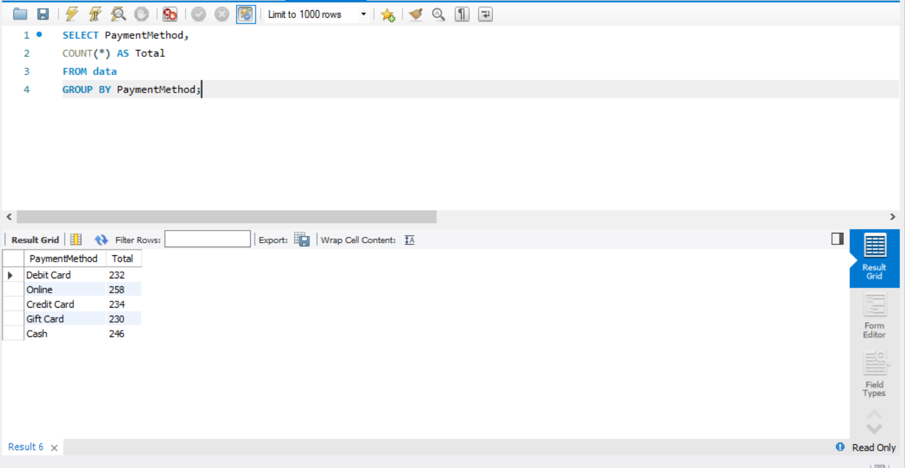

- SELECT OrderStatus, COUNT(*) AS Total FROM data GROUP BY OrderStatus;

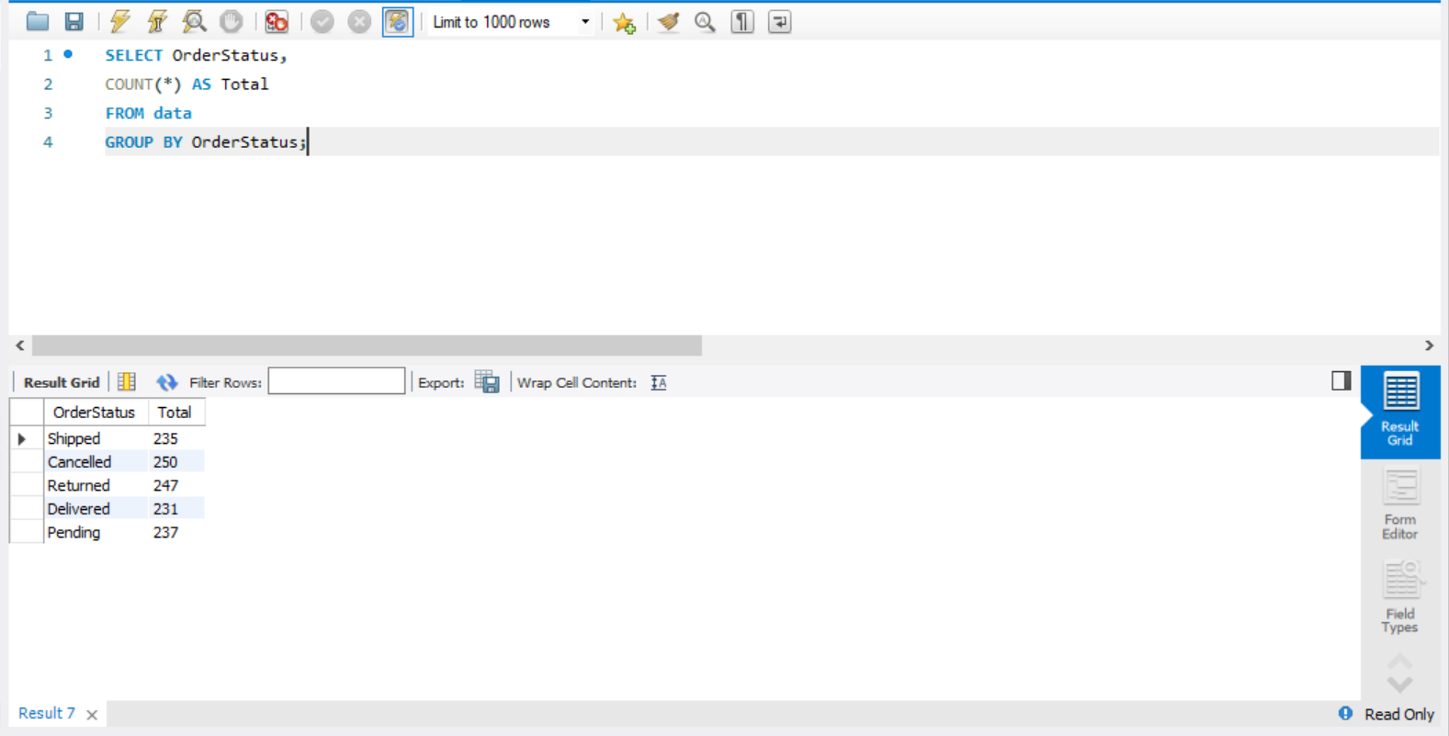

- SELECT * FROM data WHERE OrderStatus='Delivered';

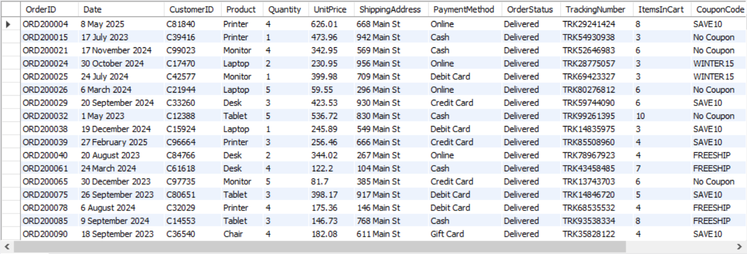

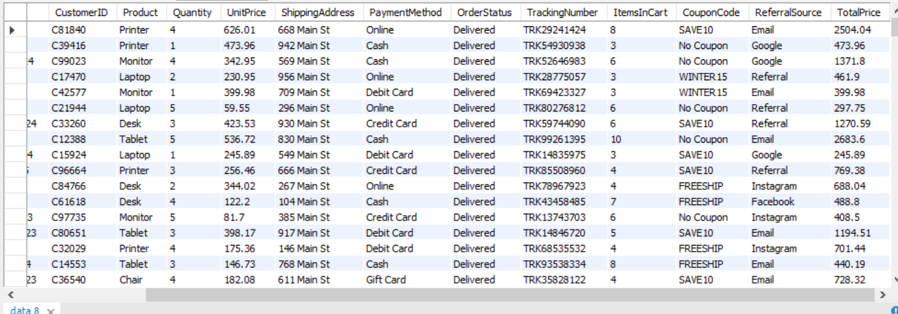

- SELECT * FROM data ORDER BY TotalPrice DESC LIMIT 10;

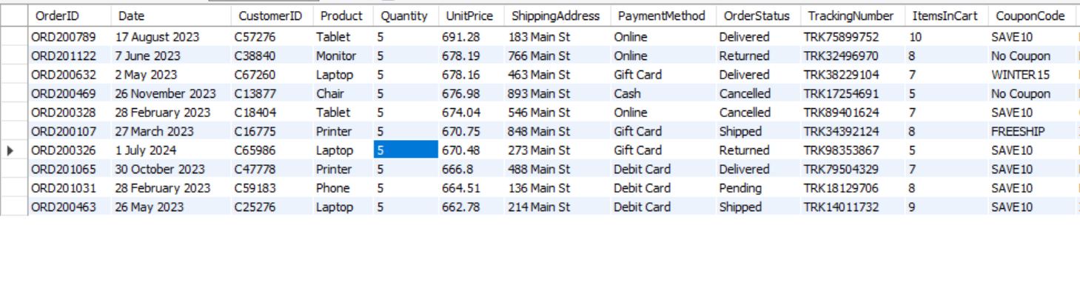

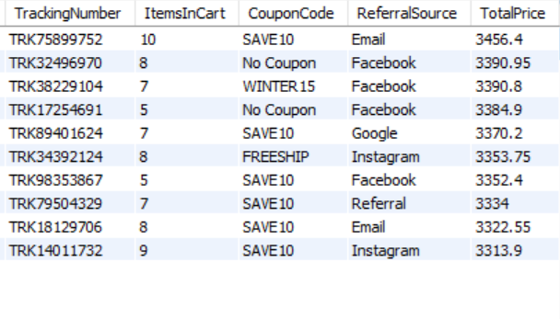

- SELECT * FROM data WHERE Quantity > 3;

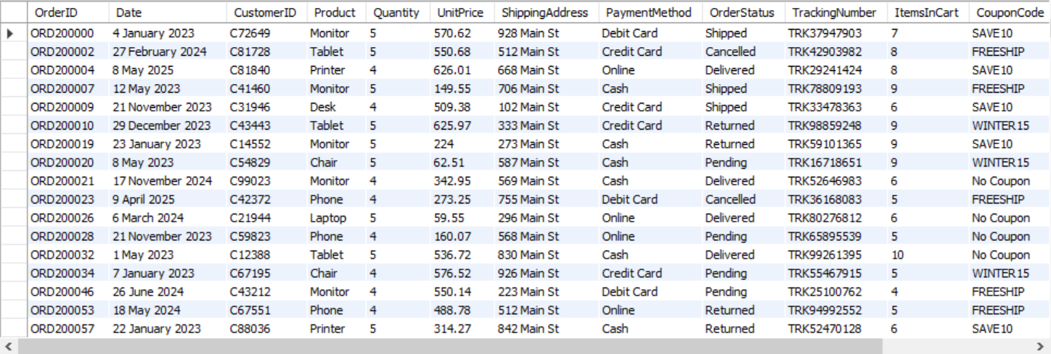

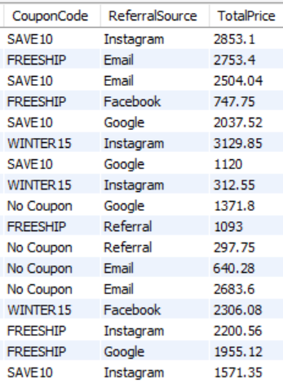

Key Insights
- Calculated total orders and sales.
- Computed averages.
- Identified most sold product.
- Analyzed payment methods and order status.
- Filtered delivered orders and highest sales.

Conclusion
- SQL was used to analyze the e-commerce dataset and extract meaningful business insights.

Author
- Huma Imam
- Data Analytics Intern
- DecodeLabs

